**EXP NO 10** Create a simple cloud software application for online super market using any Cloud Service Provider to demonstrate SaaS with the template of customer name, address, phone, email, items, quantity etc. with the item classification form.

**PROCEDURE**

**STEP 1** GO TO ZOHO.COM

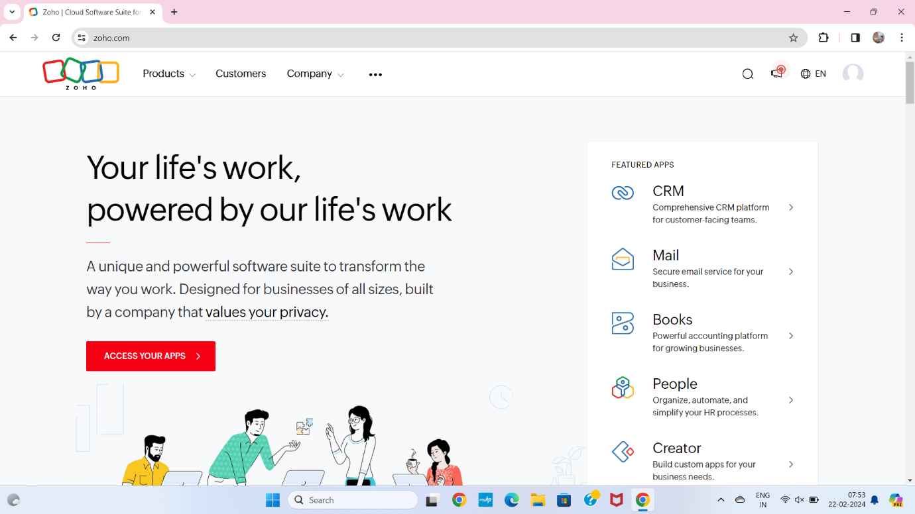

**STEP2** LOGIN TO THE ZOHO.COM

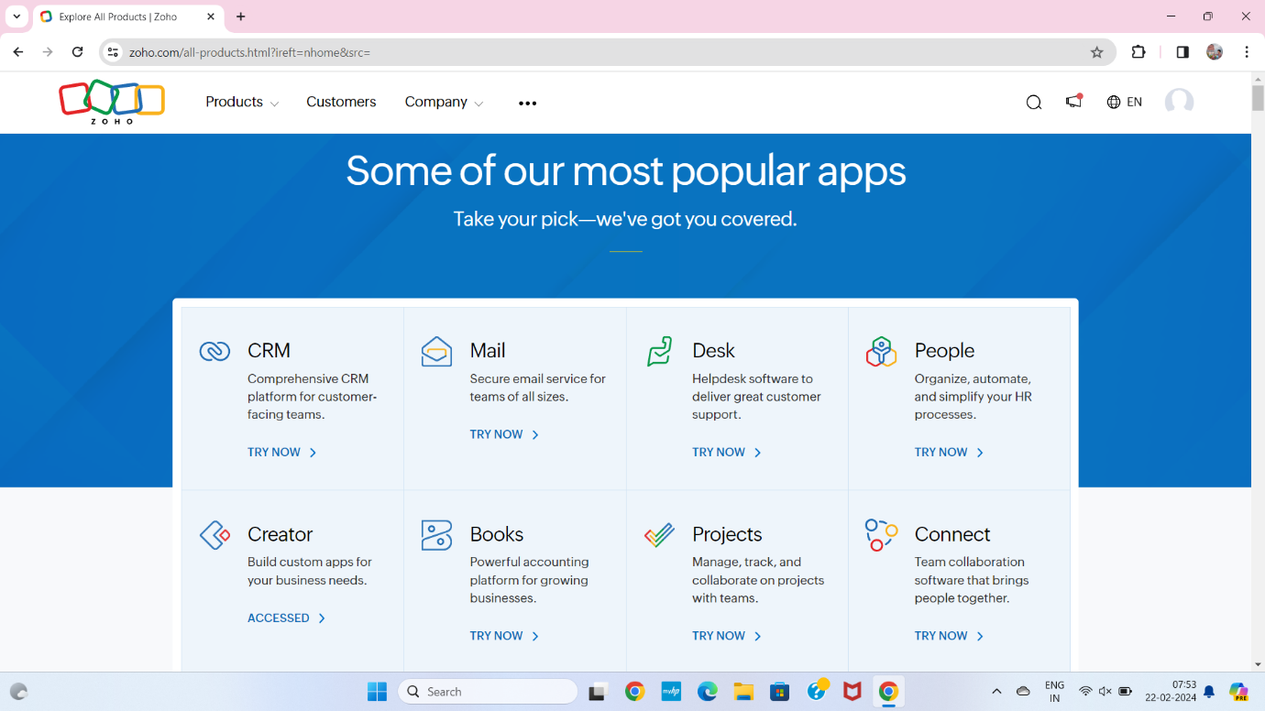

**STEP 3** SELECT A CREATE FROM SCRATCH

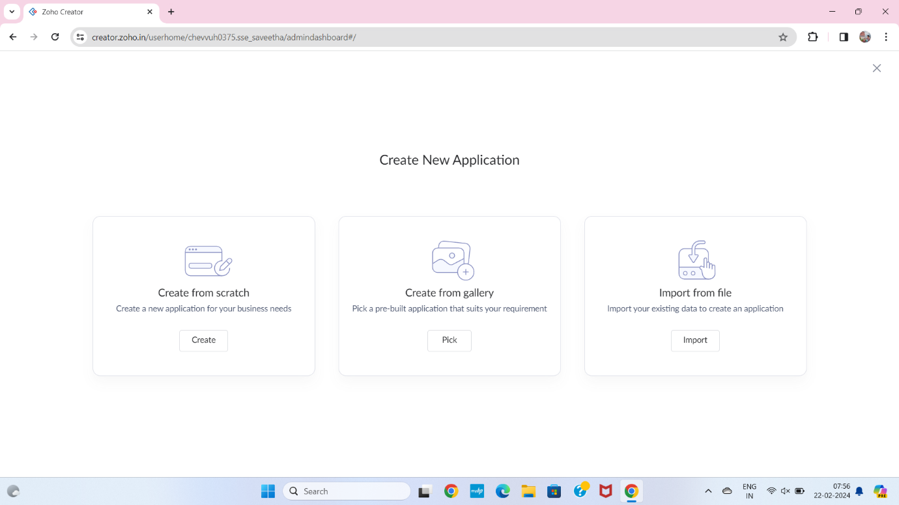

**STEP 4** SELECT APPLICATION NAME AS PROPERTY ONLINE SUPER MARKET SYSTEM

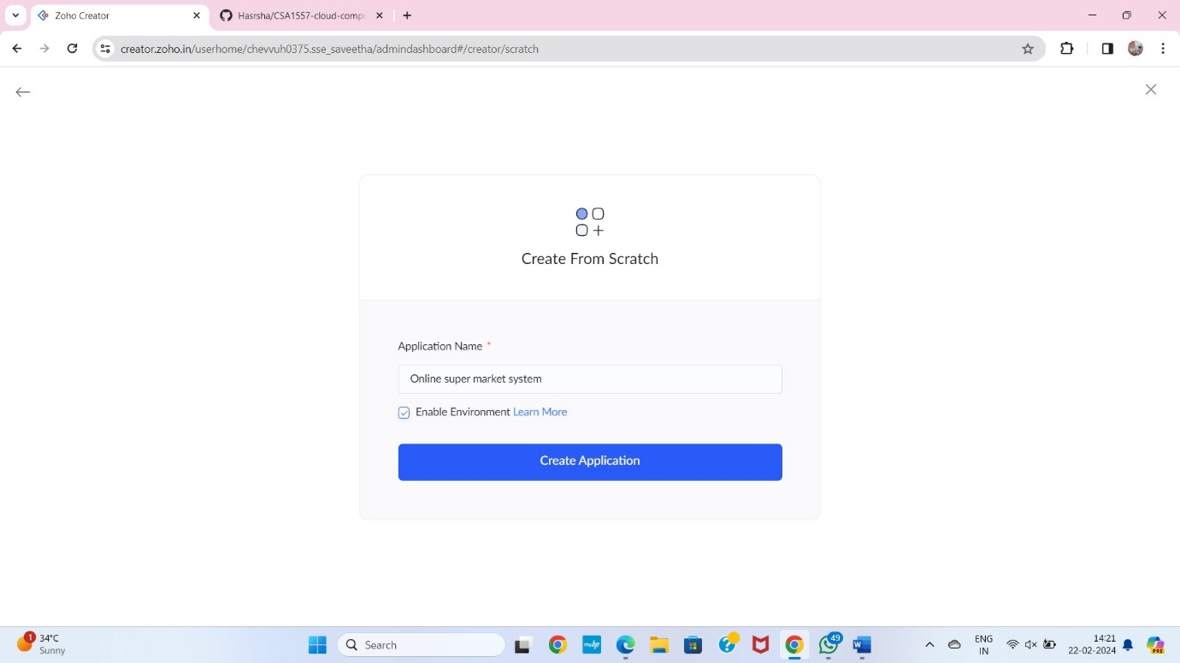

**STEP 5** CREATE A NEW FORM

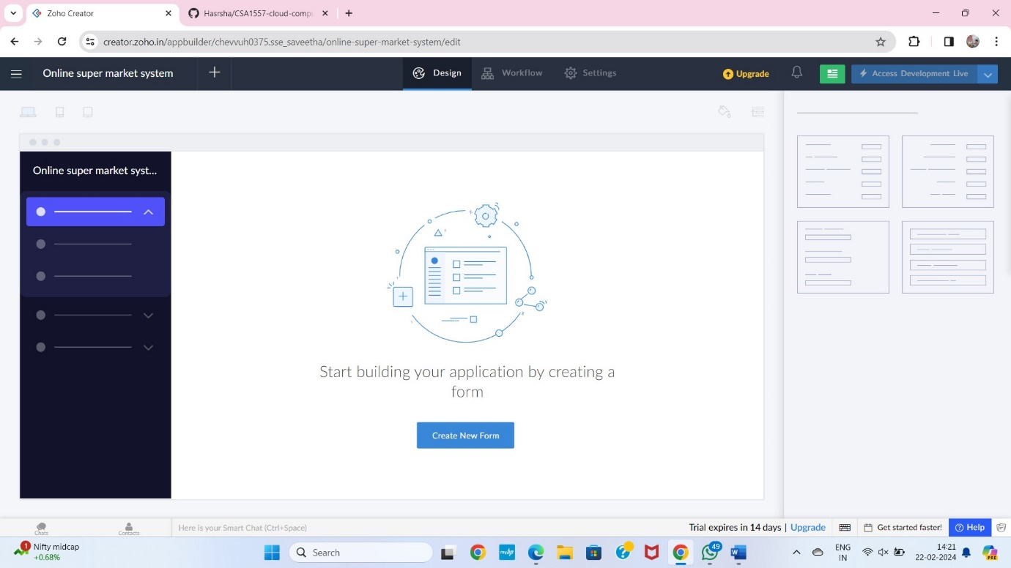

**STEP 6** SELECT BASIC FIELD FROM GIVEN BELOW AND DEVELOP APPLICATION

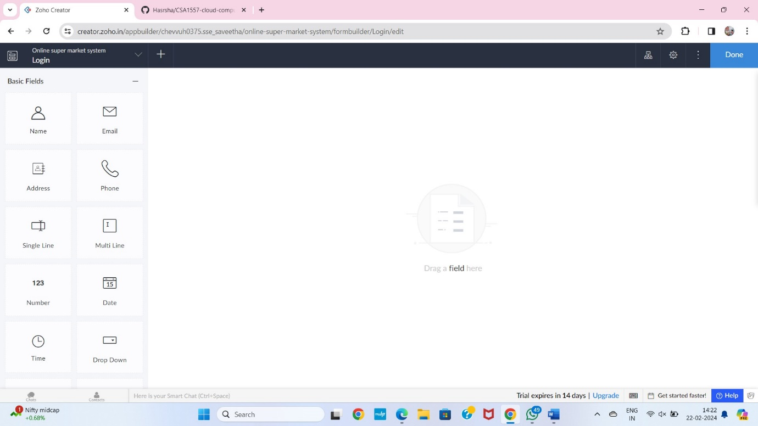

**STEP 7** THE SOFTWARE HASE BEEN CREATED LOGIN PAGE

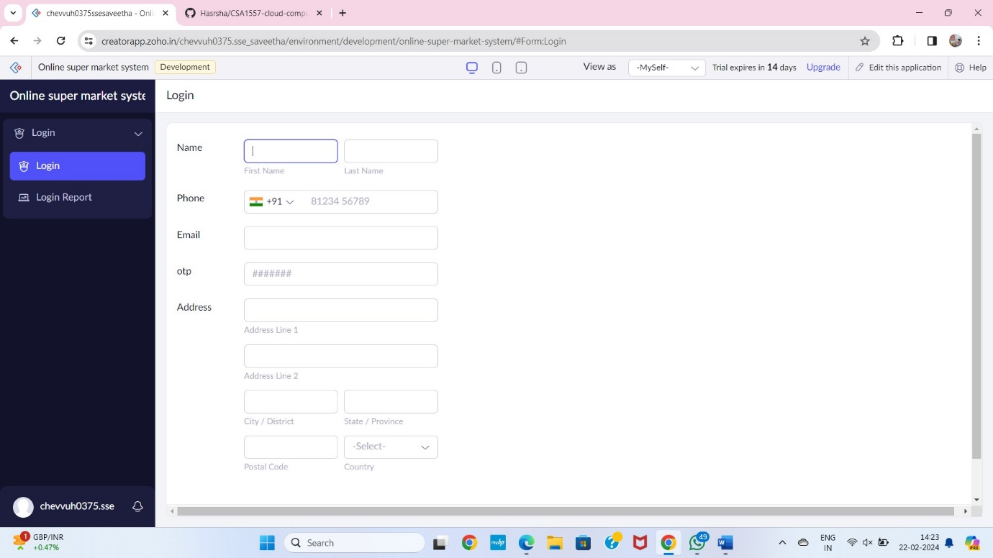

**STEP 8** THE SOFTWARE HASE BEEN CREATED SELECTING ITEMS

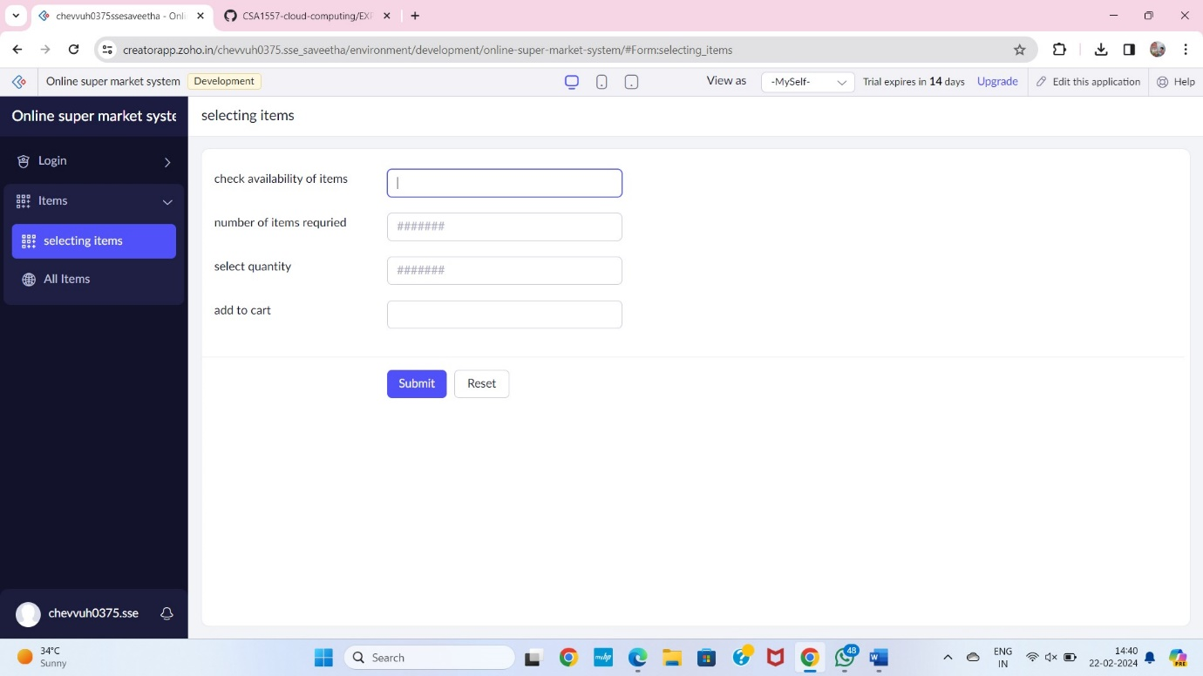

**STEP 9** THE SOFTWARE HASE BEEN CREATED DELIVERY

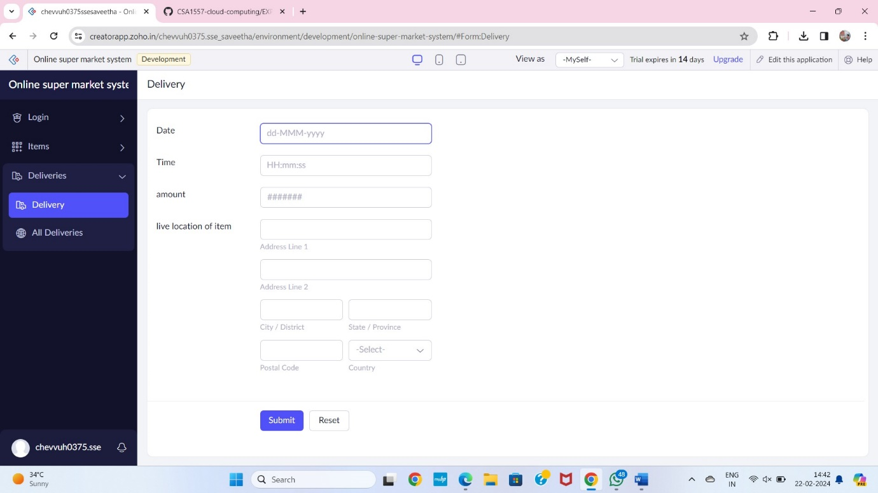

**STEP 10** THE SOFTWARE HASE BEEN CREATED PAYMENT

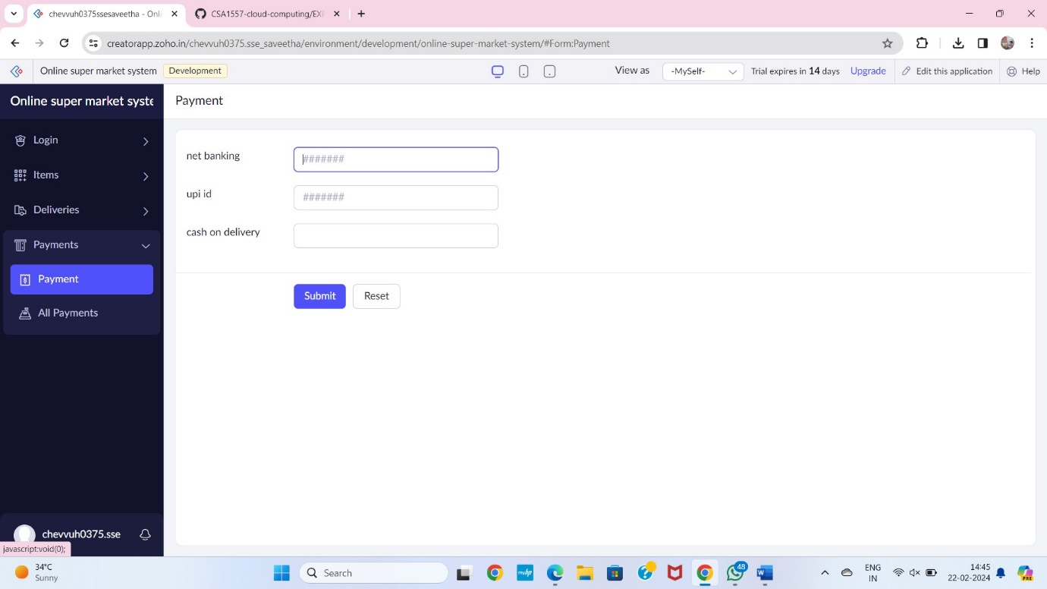

**STEP 11** THE SOFTWARE HASE BEEN CREATED COMMENTS

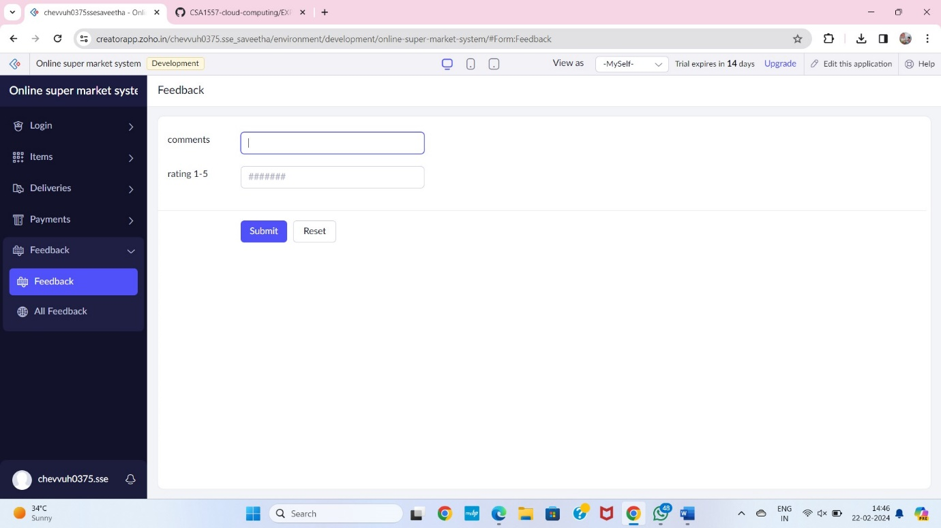

**STEP 12** THE SOFTWARE HASE BEEN CREATED

